USING DDL STATEMENTS TO CREATE AND MANAGE TABLES

1. Create table DEPT1 with the following columns: DEPTNO INTEGER PRIMARY KEY, DNAME VARCHAR2(30) NOT NULL, LOC VARCHAR2(30) NOT NULL.
SQL> create table dept1(deptno integer primary key,dname varchar2(30) not null, loc varchar2(30) not null);
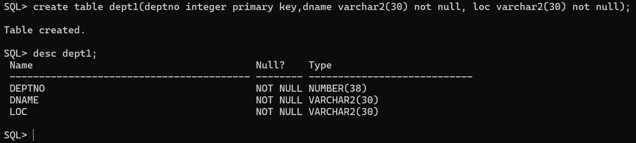

2. Create table EMP1 with the following columns: EMPNO INTEGER PRIMARY KEY, ENAME VARCHAR2(20) NOT NULL, SAL NUMBER(10,2) CHECK (SAL > 5000), MGR NUMBER (Foreign Key referencing EMP1.EMPNO), DEPTNO INTEGER (Foreign Key referencing DEPT1.DEPTNO).
SQL> create table emp1(empno integer primary key,ename varchar2(20) not null,sal number(10,2) check (sal>5000),mgr number,deptno integer, foreign key(deptno) references dept1(deptno));
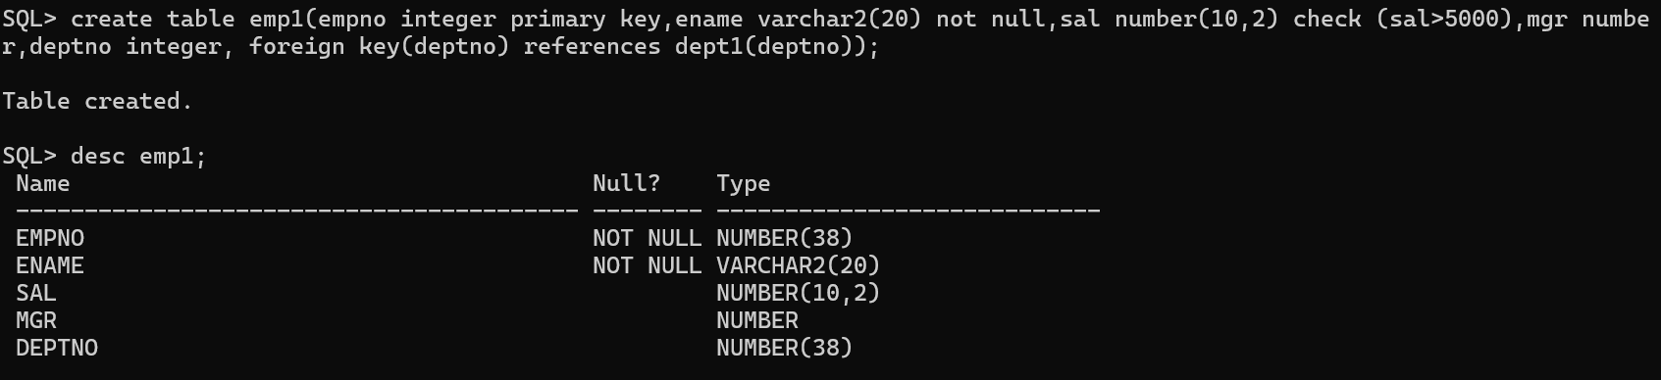

3.Create tables DEPT11 and EMP11 by copying DEPT1 and EMP1.
SQL> create table dept11 as select * from dept1;
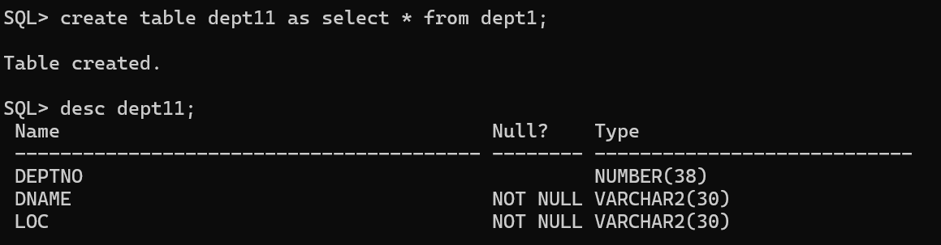
SQL> create table emp11 as select * from emp1;
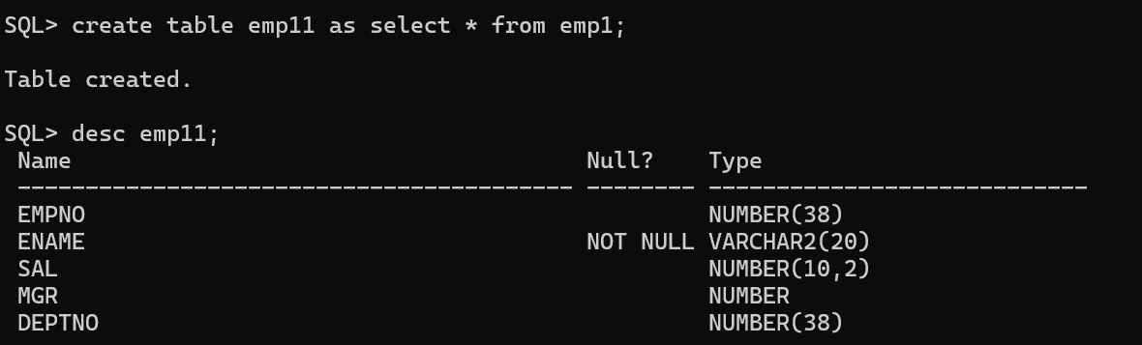

4.Add a new column ADDRESS VARCHAR2(30) to the EMP1 table.
SQL> alter table emp1 add Address varchar2(30);
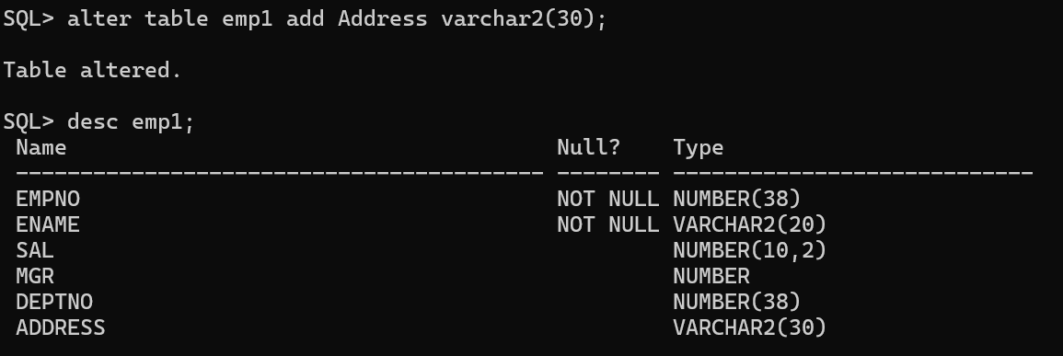

5. Rename the SAL column in EMP1 to SALARY.
SQL> alter table emp1 rename column sal to salary;
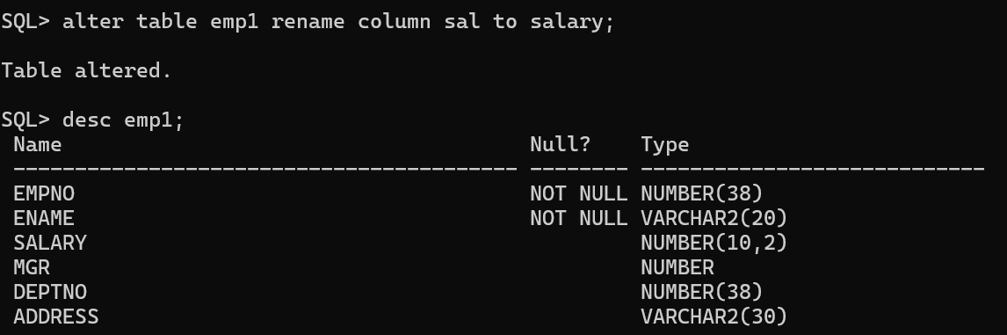

6.Rename the foreign key constraint names in EMP1 and verify the constraint names.

SQL> SELECT constraint_name,
constraint_type,
table_name
FROM user_constraints
WHERE table_name = 'EMP1';
SQL> ALTER TABLE EMP1 RENAME CONSTRAINT SYS_C007845 TO FK_EMP1;
Table altered.

7.Increase the size of the ENAME column to VARCHAR2(40).

SQL> alter table emp1 modify ename varchar2(40);
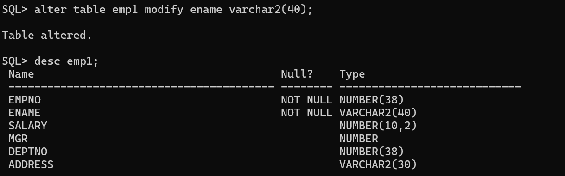

8. Drop the NOT NULL constraint on the ENAME column.

SQL> ALTER TABLE emp1 MODIFY ename varchar2(40) NULL;
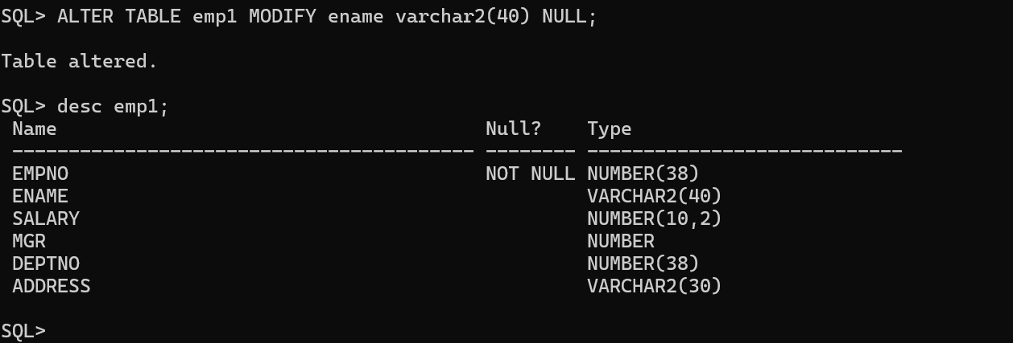
9.Create a comment on the DEPT1 table as 'Depts of WIPRO'.
SQL> comment on table dept1 is 'Depts of WIPRO';

Comment created.
10.Create a comment on the DEPTNO column of DEPT1 as 'Deptno of WIPRO'. SQL> COMMENT ON COLUMN dept1.deptno is 'deptno of WIPRO';
Comment created.

11. Create a comment on the EMP1 table as 'Employees of WIPRO'.

SQL> comment on table emp1 is 'Employees of WIPRO';

Comment created.

12.Create a comment on the EMPNO column of EMP1 as 'Empno of WIPRO'.
SQL> COMMENT ON COLUMN emp11.empno is 'empno of WIPRO';

Comment created.

13.Remove all comments from the tables and columns.

SQL> COMMENT ON table emp1 IS ' ';
SQL> COMMENT ON COLUMN emp1.empno IS ' ';
SQL> COMMENT ON table dept1 IS ' ';
SQL> COMMENT ON COLUMN dept1.deptno IS ' ';

14.Mark the SALARY and ENAME columns of EMP1 as UNUSED.
ALTER TABLE emp1 SET UNUSED (salary,ename);
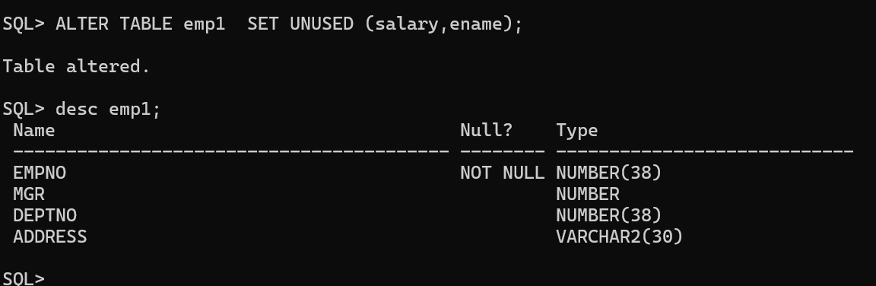

15.Drop the UNUSED columns from EMP1.
ALTER TABLE emp1 DROP UNUSED COLUMNS;

16.Drop the EMP1 and DEPT1 tables.
SQL> drop table emp1;
Table dropped.

SQL> drop table dept1;
Table dropped.
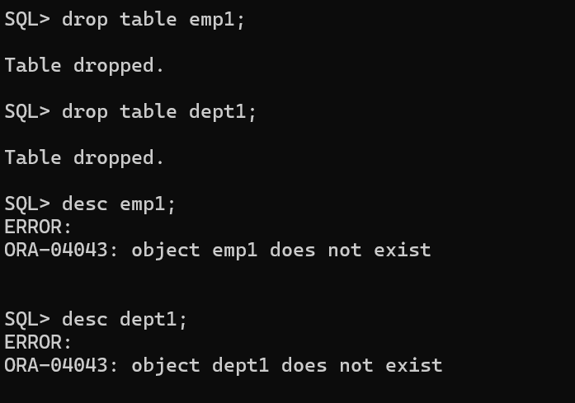

17.Create table EMP1 from the EMP table by copying both the structure and data. Verify the data.
SQL> create table emp1 as select * from emp;
Table created.
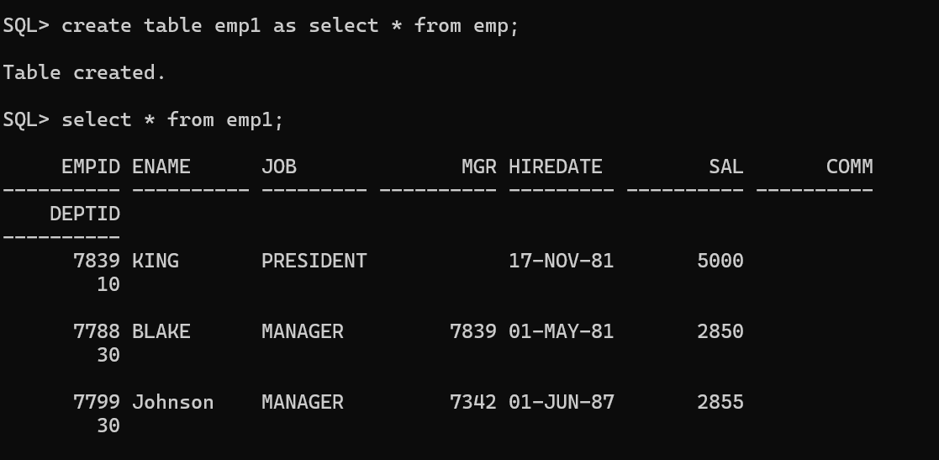

18.Rename EMP1 to EMP_TEST.
SQL> alter table emp1 rename to emp_test;
Table altered.
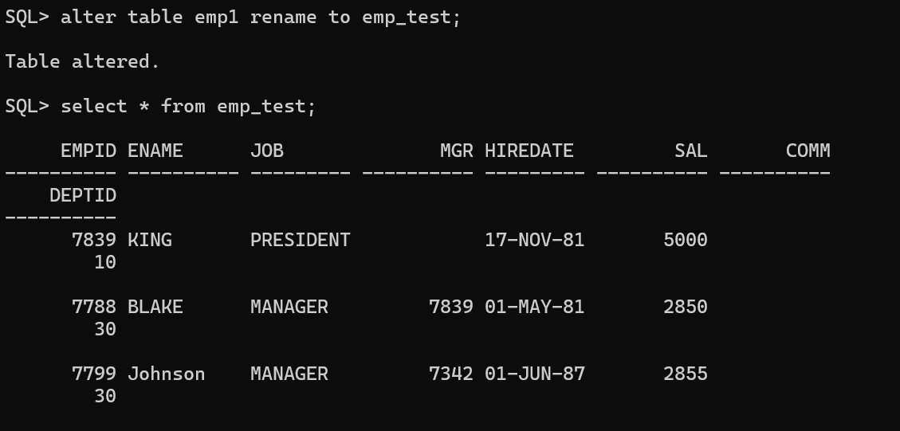

- Truncate the EMP_TEST table and verify that all rows have been deleted.
SQL> truncate table emp_test;

SQL> select * from emp_test;

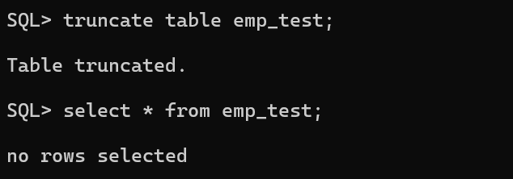

20.Create table EMP2 from EMP by copying only the EMPNO, ENAME, and SAL columns along with their data.
SQL> create table emp2 as select empid,ename,sal from emp;
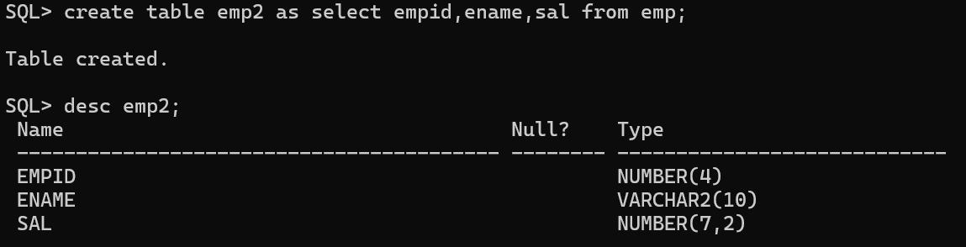

21.Drop the EMP2 table.
SQL> drop table emp2;
Table dropped.
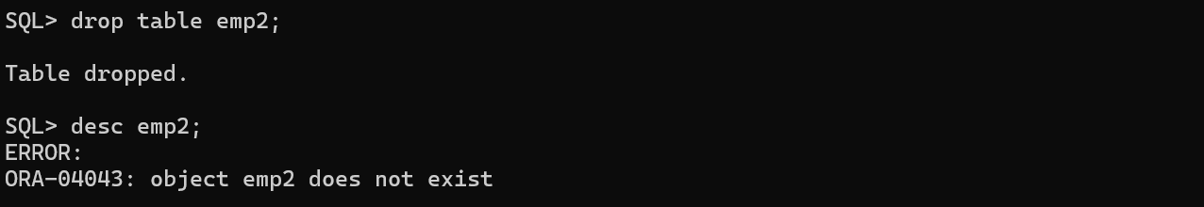

22.Create the EMP2 table again from EMP without copying any data.

SQL> CREATE TABLE emp2 AS SELECT * FROM emp WHERE 1=0;

Table created.

SQL> desc emp2;
Name Null? Type
----------------------------------------- -------- ----------------------------
EMPID NUMBER(4)
ENAME VARCHAR2(10)
JOB VARCHAR2(9)
MGR NUMBER(4)
HIREDATE DATE
SAL NUMBER(7,2)
COMM NUMBER(7,2)
DEPTID NUMBER(2)

SQL> select * from emp2;
no rows selected
23.Drop the EMP2 table.
SQL> drop table emp2;
Table dropped.

24.Flashback the first dropped EMP2 table (containing data) and verify the table.
SQL> FLASHBACK TABLE emp2 TO BEFORE DROP;
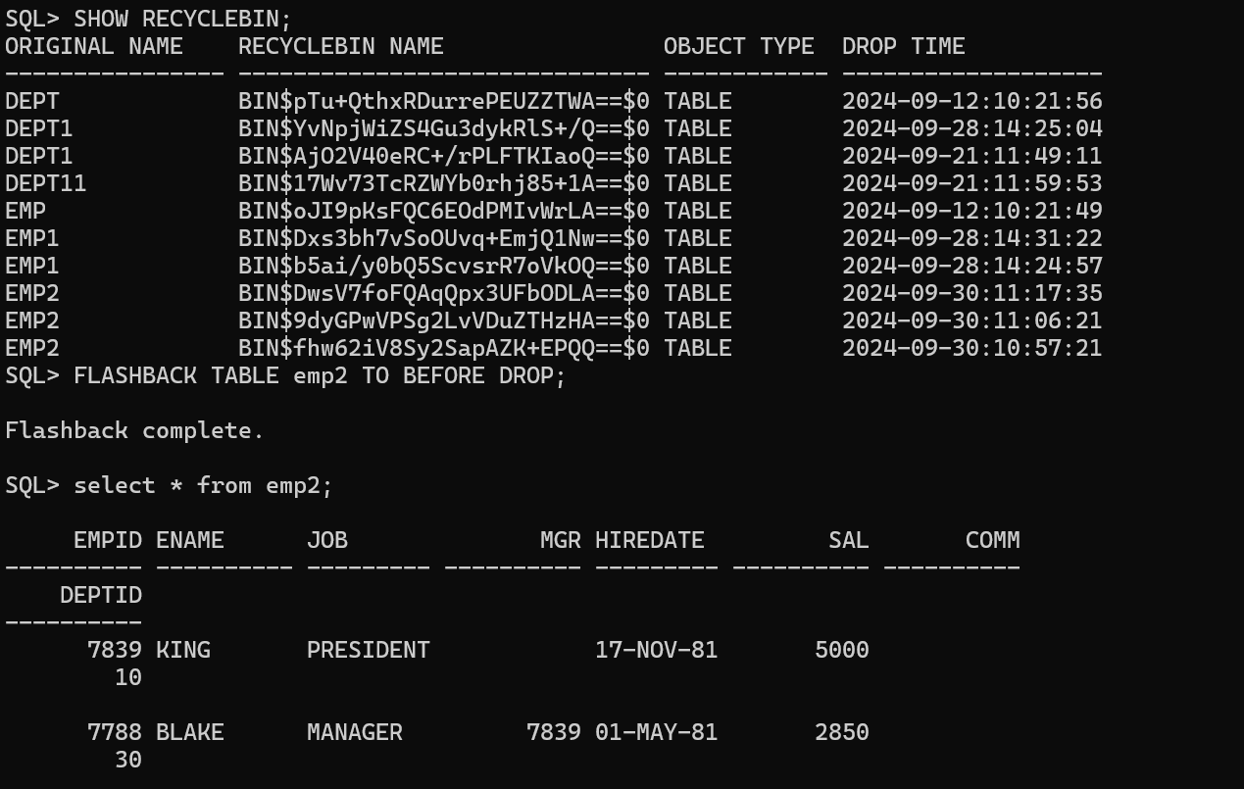

25.Flashback the recently dropped table and restore it as EMP2_1.
SQL> FLASHBACK TABLE emp2 TO BEFORE DROP RENAME TO emp2_1;

Flashback complete.
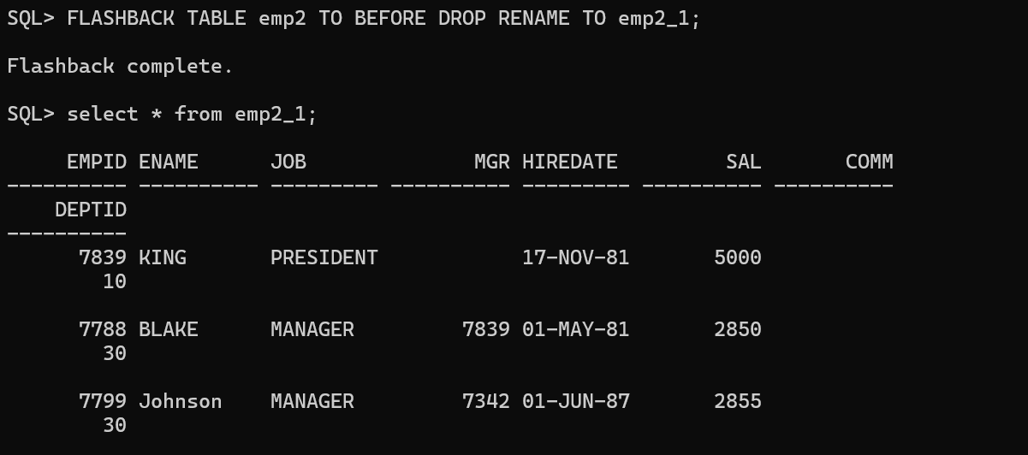

26.Display all tables owned by the current user.

SQL> SELECT table_name FROM user_tables;

TABLE_NAME
------------------------------
REGIONS
LOCATIONS
DEPARTMENTS
JOBS
EMPLOYEES
JOB_HISTORY
DEPT
EMP
LODGE_DETAILS
SKILL_DETAILS
EMP_DETAILS

TABLE_NAME
------------------------------
EMP_SKILL
DEPT11
EMP11
STUDENT
SALGRADE
DEPT_1
EMP_1
PRODUCTSTB
DEPT1
EMP2_1
COUNTRIES

TABLE_NAME
------------------------------
EMP_TEST

23 rows selected.

